We would like to thank the Bill and Melinda Gates Grand Challenge organization for awarding NHN this Phase 1 grant. It opened global doors that facilitated astonishing results.

Summary Conclusions and Support of Our Hypothesis: Our hypothesis involved designing a device that would utilize urine to flush waste through a pour-flush (PF) toilet thus reducing or eliminating the need for scarce flush water during the dry season in developing countries. We hypothesized such a device would reduce the burden of fetching water from long distances during the dry-season and thus reduce the tendency for rural villagers to return to open defecation when water is scarce. Our hypothesis went on to posit that the urine-flush device would encourage the use of latrines and help reduce incidents of diarrhea and other water related illness by 35%.

Other sources of project support included collaborations with four nonprofit organizations (NGOs) in Cambodia including the World Toilet Organization (WTO) – leaders in sanitation marketing, PLAN-Cambodia – leaders in behavioral change, Wetlands Work – leaders in biological waste treatment, and Resource Development International Cambodia (RDIC) – leaders in household water treating, filter manufacturing and unusual prototype construction. Their in-kind support is reflected in our Phase 1 Financial Report included in our uploaded files and described further below.

Several designs were prototyped and tested in the USA. Two of the most promising designs were manufactured and field tested in three rural villages in Cambodia. The Flush-Pumps used for field testing were made in Phnom Penh by RDIC out of PVC pipe fittings for $12.50 each. We investigated the potential cost reduction offered by mass production with the Cambodian plastics extrusion manufacturer Cambox. Cambox stated their cost for plastic pellets alone would exceed that of the PVC and suggested we continue to use PVC fittings.

Three households that already had standard pour-flush toilets in three rural villages were asked to test the flush-pumps. We offered to install the pumps free of charge if they would kindly give us feedback on its use. Installation by local craftsmen averaged four hours. The most important attribute of the pump proclaimed by the users was the ease of flushing. They liked the feel of the quick push of the pump handle to flush their toilet. The second most attractive attribute was the reduction in flush water and the resulting need to carry only half as much water as usual for flushing and hand washing.

Regarding the burden of fetching water, we found that the users were reluctant to use urine for flushing. This was based on the discomfort they had around the idea of using urine, not the functionality of its use or odor issues. They pointed out that they would still need to fetch water for handwashing at the toilets even if it was not needed for flushing.

The three heads of households that agreed to test the flush pumps indicated a $15US cost would be acceptable because they liked the way it flushed and were eager to show it to their neighbors. Our actual cost was $12.50.

One unit worked very well throughout a three month test period. All family members of the household, ranging in ages from 15 to 47, were very happy with the systems. The other two test households liked the idea and convenience that the flush-pump offered, but the flushing was not thorough. There is evidence that the latter two ceramic toilet bowls had a problematic exit lip causing an impediment to moving the waste through the bowl. NHN removed these two units before departing Cambodia and restored the latrines to their original design.

Challenges to Be Addressed in Phase 2: We did not have time or resources to scale-up mass installation or determine if the Flush-Pump would contribute to a 35% reduction in household incidents of diarrhea. Although our Flush-Pump offers an affordable, attractive option that promotes the use of PF-toilets in the dry seasons, we discovered that the existing PF-toilet designs being installed and widely promulgated are problematic; they do not offer a closed-loop sanitation system. First, they do not offer any means of safely removing or disposing of sludge that eventually accumulates in the septic tank rings. Second, none of the fecal/urine nutrients are available for use as an agricultural fertilizer. Third, although there are several NGOs promoting the sale of thousands of PF-toilets in Cambodia via sanitation marketing, none of the sanitation marketing programs are currently addressing the inability of the poorest of the poor to afford the $50 to $70 PF-toilet kits. We intent to address these issues in our Phase 2 grant application. We are fortunate to have the personal support of Dr. Chea Samnang, Director of Rural Health Care for the Ministry of Rural Development. He is responsible for government activities concerning rural sanitation in Cambodia and meeting new MDG goals targeting 2025. He offers his department’s support for our Phase 2 activities on a national, provincial, and district level.

Activities and Experiments Conducted:

The first step in testing our hypothesis was to design an apparatus that could use urine as a flush media. The design criteria were:

- It must use less than 1,500 ml of liquid to adequately flush a PF toilet containing an average size pile of feces.
- Urine collection and storage should be at a low and convenient elevation.
- It should be affordable to the poor and cost less than $10.
- It should be able to be manufactured and maintained locally – potentially by the user.
- It should be able to be retrofitted to the existing PF-toilets and easily integrated into new installations.
- It should be hygienic to use, free of odor, and not attract flies.
- It must be robust and easily maintained.
- Villager demand for the kit should be easy to create.
The maximum 1,500 ml per flush criteria was based on our literature review of several research papers that indicated a healthy adult urinates approximately 1,500ml per day. Assuming a healthy person defecates once per day, we concluded we would have 1,500ml of urine available to flush one fecal pile. In reality, our household surveys indicated that villagers defecate an average of 1.25 times per day and urinate an average of five times each day. None of the PF-toilet owners consistently urinate in their toilets. They tend to urinate close to their houses or in the rice fields because they view urine different than feces; less dirty, less disgusting, less disease inducing, and less odorous.

A mockup of a PF-latrine was built in Houston, Texas for testing the PF-bowl flushing behavior. It became evident that the efficiency of flushing was proportional to the energy in the stream of liquid being used to flush the pile. However, our second design criteria limited the height of the urine collection to that of a typical urinal. Stored urine at an elevation of one-half meter did not provide enough kinetic energy to move the fecal pile form the bowl. The conclusion of these experiments was that we would need to pressurize the urine with a manual pump (see Figure 1).

PVC pipe was selected as the construction material for the pump. Twenty-liter drinking water jugs were used for urine collection and storage. Tubing was used to interconnect the components. All of these components are readily available in villages as small as 1,500 people. They are inexpensive, rugged, and easy to work with for local craftsmen.

Three Flush-Pumps with varying diameters and lengths were tested. The design eventually selected is made of standard 75mm diameter PVC drain pipe. It has a stroke of 24cm with an overall pump height of 108cm. The 24cm stroke gives 1000ml of flushing volume however, due to air ingression after each flush, the actual volume delivered to the PF bowl is 750ml per plunger push.

Figure 1 is a schematic of the overall Flush-Pump kit that was field-tested. The PF-bowl, chamber box, and three-ring septic tank (not shown) already existed at the trial households. Our Phase 2 grant application will address the rest of the system including the septic tank, and a method to treat urine/waste-water effluent so that it can be recycled back to the urine reservoir for further flushing or safely used as crop fertilizer. We will also address safe removal and disposal of the septic tank sludge. Our intent is to create an affordable closed-loop system (see Phase 2 application for details).

Starting from the left in Figure 1, the overflow reservoir is used to capture excess urine/waste-water and allow for pasteurization of the contents when oriented to direct sunlight. This allows it to be safely used as agricultural fertilizer after a two week exposure. The urinal is made from a standard, plastic, 20-25 liter jug with a central spout. An opening is cut into the inverted jug using a hand saw or knife. Urine or any supplemental liquid such as dishwashing water or muddy water from a rice paddy is poured into the urinal and passes into the urine reservoir via either a dip-pipe (shown) or a P-trap made of 21mm tubing. The dip-pipe or P-trap reduces urine odor at the urinal opening. Three milliliters of cooking oil can be added to the urinal for odor control. The oil floats on the urine in the trap and blocks the urine odor. We found this oil was not necessary. Wind in the area was enough to eliminate noticeable odor. Interestingly, all households requested the urinal be mounted to an exterior wall of the latrine.

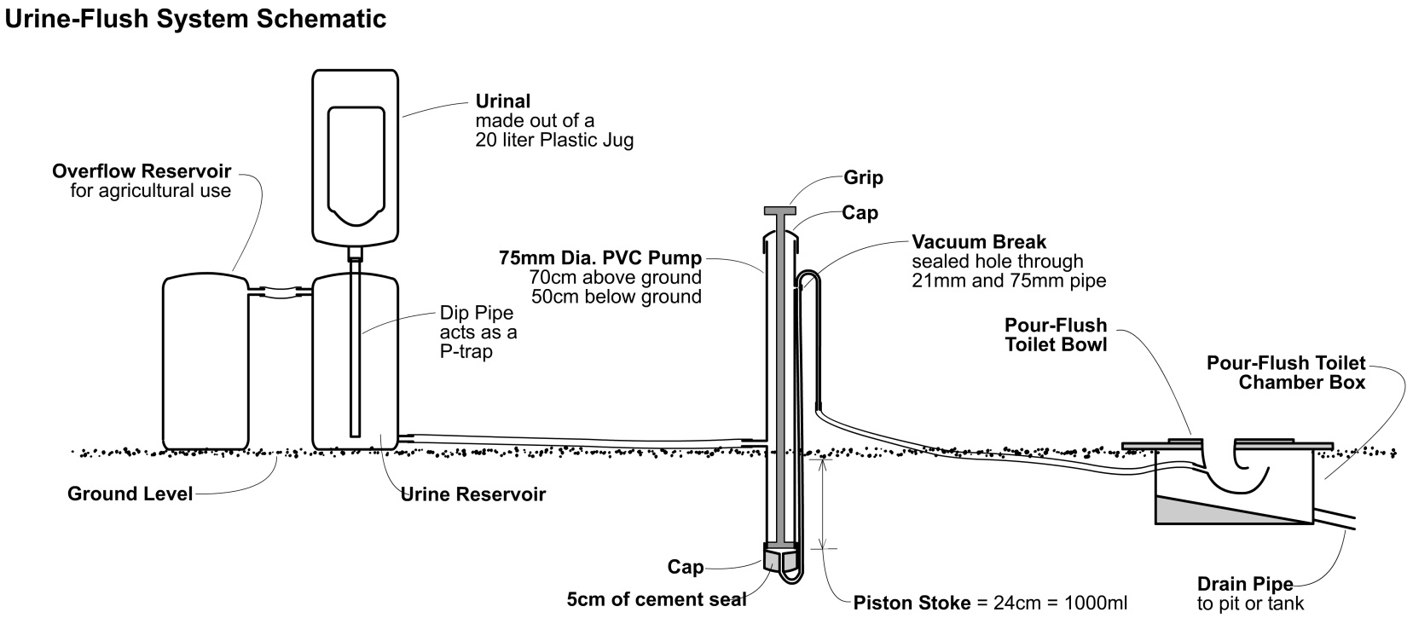

Figure 1

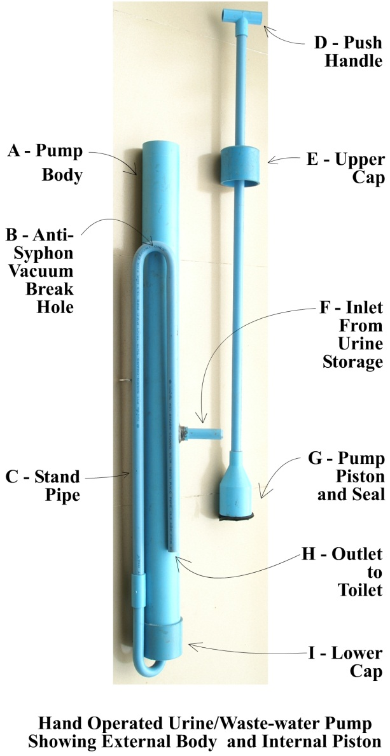The Flush-Pump discharge “S” tube is made by bending a straight piece of 21mm PVC pipe. The pipe is filled with sand, heated over a cooking fire until it is pliable, and then bent to the appropriate shape. The sand keeps the pipe from kinking while it is being bent. Bending the 21mm PVC pipe in this way eliminates four 90^{O} PVC elbows and their associated cost. This technique is commonly practiced in developing countries by the ever resourceful village craftsmen.

It is important to note the elevation of the various kit components. Use of gravity is a key feature in the design. The top of the pump exceeds the height of the urinal insuring that there is no spillage of liquid from the top of the pump as the urine storage tank fills and empties. Any overflow will be at the urinal where it is easily detected by the user and corrected by either urinating in the PF-toilet, or connecting an optional overflow reservoir jug. The discharge of the Flush-Pump is bent upward in the form of an “S” to a height above that of the urinal. This insures the liquid in the urine reservoir cannot drain by gravity into the PF-toilet.

The outlet of the pump is connected to a nozzle at the back of the PF toilet bowl. The nozzle is a standard 21mm PVC pipe to tubing nipple. The nozzle is installed into existing ceramic bowls by 1) removing the PF-toilet floor - it is easily lifted from the chamber box after using a hammer and chisel or large nail to break the cement seal, 2) drilling a hole at a 30^{O} downward angle through the back of the bowl at the water line, 3) shaping the PVC nozzle with sandpaper or a knife to fit smoothly in the bowl, 4) glueing the nozzle in place with quick setting epoxy glue, 5) connecting the hose that leads to the pump to the nozzle, 6) chipping a U-shaped hole in the back of the cement flush box, 7) setting the floor back on the cement box guiding the connection hose through the U-shaped hole in the box, and 8) securing the floor to the box and filling all openings with about five-handfuls of wetted cement. Figure 2

The pump (see Figure 2) has several interesting design features. It requires no check valves and all passages are large enough to accommodate dirty flush liquids. The upper cap “E” is drilled to accommodate the piston. The lower cap “I” is drilled to accommodate the 21mm discharge S-pipe. Cement is used to seal the discharge pipe to the bottom cap. This avoids the need for an expensive PVC reducer.

One critical feature is the small hole drilled at the apex of the pump discharge tube (see Vacuum Break in Figure 1, or item “B” in Figure 2). Whenever the pump is used, a syphon is created between the low lying toilet bowl and the higher urine reservoir. The purpose of the small hole at the apex of the pump discharge pipe is to eliminate the syphon suction by allowing air into the highest point of the liquid path.

The apex of the discharge pipe is epoxy glued to the side of the pump body using a generous amount of epoxy. After the glue hardens, a 2mm hole is drilled from right to left through the 21mm discharge pipe, the epoxy, and the pump housing. The outside hole is plugged with epoxy or a small, short screw. The small amount of liquid wasted through the anti-syphon hole during the down-stroke is returned to the pump body for reuse.

The piston is the only moving part. It is made with a standard PVC reducer and a 120cm length of 21mm PVC pipe for the shaft. The piston OD and pump body ID differ by 4mm. This allows water to pass easily from the top to the bottom of the piston during the up stroke. The “floppy” piston seal is made in three pieces. The first is made of used truck tire inner-tube. Its diameter is a loose fit to the pump ID and does not have to be perfectly round. The second and third seals are made of plastic tarp. They are cut with a diameter 3mm bigger than the pump ID. They do not need to be cut perfectly round. Some amount of liquid slippage on the down stoke is expected and tolerable (see Figures 3a, b, and c).
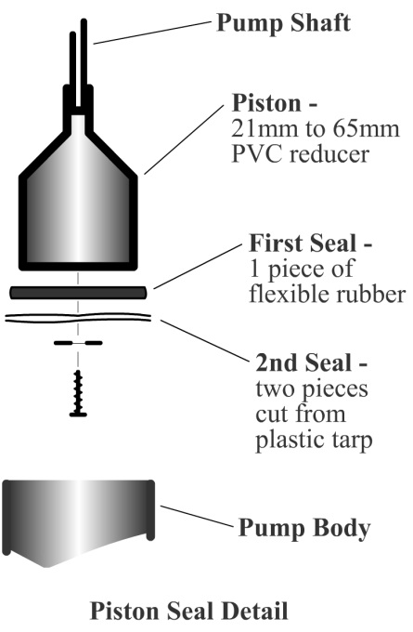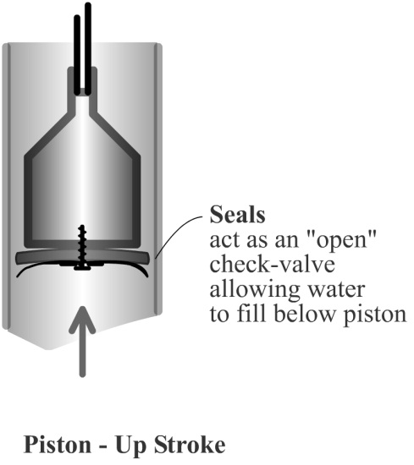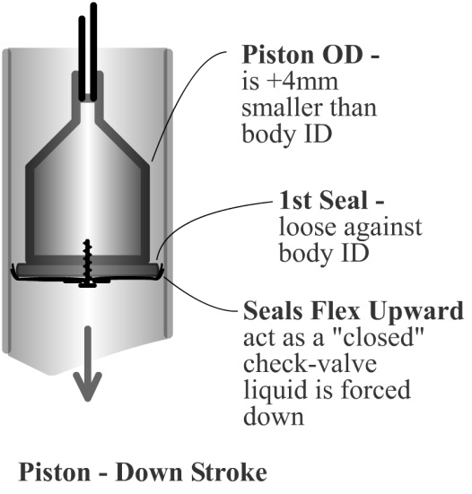

Figures 3a, b, and c

Odor control was easier to attain than expected. We designed and tested two devices that automatically add cooking oil to the each flush. The oil floats on the urine surface of the PF-toilet bowl liquid seal blocking any odors from escaping to the environment. However, there is very little odor especially in applications where the toilet is located outdoors. We therefore elected not to complicate the design with an automatic oil injection system. We may need to revisit this feature for indoor PF-toilet applications in Phase 2.

Although our Phase 1 application stated we would test units in Africa, Cambodia offered a better venue to find villagers, manufacturers, and installers with PF-toilet experience. It also offered a six-month dry season.
In addition to the urine-flush pump development, NHN conducted our Community Driven Water, sanitation, and hygiene (CDWaSH) program in four villages to build demand for 1) effective sanitation practices, 2) household water treating with sunlight (SODIS), and 3) making oral rehydration solution. Although we successfully addressed items (2) and (3), the wet-season rains interrupted our facilitating permanent sanitation behavior change activities.

Data Gathered and Results Obtained:

One kit was installed by a local craftsman in a rural village in the Angkor Chum District of North-West Siem Reap Province. Two were installed by a local craftsman in the central province of Kampong Chhnang. We found villagers could use as little as 750ml of liquid (waste-water or urine) to flush a pile of feces through the PF-toilet bowl. No more than two flushes were needed to clear the bowl. This was within our design parameter of using a maximum of 1.5 liters of liquid to flush the PF-toilet. In Comparison, the standard method of pour flushing by the villagers uses 3 to 5 liters of water.

Unlike the unit installed in Angkor Chum, neither of the units installed in Kampong Chhnang flushed the bowls thoroughly. We adjusted the nozzle angle without success. We were subsequently informed that the Kampong Chhnang ceramic bowls may have been sourced form a supplier that cast the bowls with an elevated discharge lip which can impede flushing efficiency. We were privy to this information the last two days of our third and final visit to Cambodia; too late to verify cause and effect.

Our field research indicated the male and female adults would tend to urinate wherever they were working and not necessarily at a PF-toilet. Also, although some women stand to urinate (witnessed in Senegal), Cambodian women squat while urinating. This limits the amount of urine available for flushing. Our design was expanded to utilize waste dishwashing water and other dirty sources of water for flushing to supplement the urine.

We will address the collection of women’s urine and closing the loop on the PF-toilet system in our Phase 2 application. In Phase 2, we intend to test a reconfiguration of the existing PF-toilet septic tank components to allow the safe collection and treatment of black-water from a septic tank using a homemade biofilter. This will allow both male and female urine-blackwater to be recycled back to the urinal for additional toilet flushes or safely used for crop fertilizer.

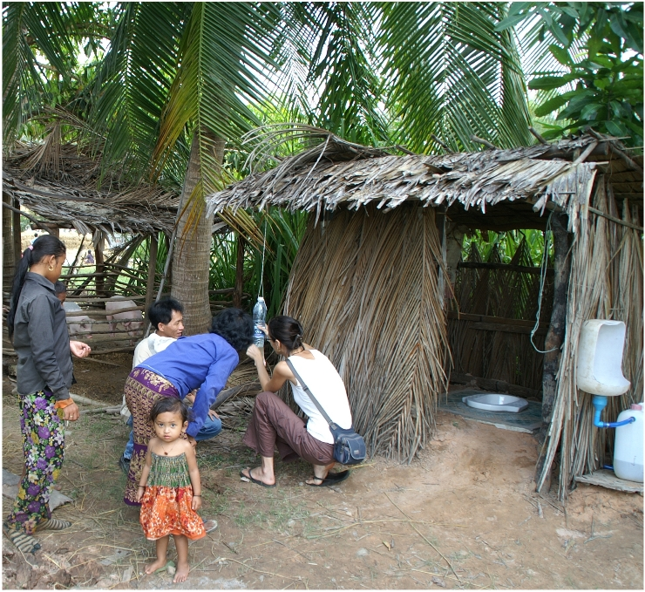Other Sources of Project Support: Several of our Cambodian NGO colleagues offered support. Jack Sim at the World Toilet Organization (WTO) offered us lodging, translators, and transportation. He introducing us to WTO’s Sanitation Marketing network and offered it as marketing platform for the Flush Kit. Prashant Verma with PLAN-Cambodia offered us housing, translators and transportation in remote areas of Siem Reap Province. They introduced us to their experiences applying Community Led Total Sanitation (CLTS) in rural villages and the difficulties we might encounter with applying the technology to the poorest f the poor. Marc Hall of RDIC offered to have one of their inventor employees, Vanna Som, build our prototypes out of locally available materials.

In return, we trained their field-staff on our Community Driven Water, Sanitation, and Hygiene (CDWaSH) program that NHN has developed to promote behavior change in rural villages that practice outside defecation. CDWaSH addresses water purification, sanitation, hand washing, and homemade oral rehydration solution simultaneously without inducing shame.

Completed Angkor Chum Urine-flush system installation -
Respectfully submitted by Mark Illian – Executive Director Monika teaching Tippy-Tap use and maintenance

Phase I Grand Challenges Explorations Financial Report

Organization Name: Nature Healing Nature
Project Title: Moving Waste with Waste

Report Type: Final | Final
Reporting Period: MM/DD/YY | 04/11/2011 | 05/16/2012

Total Expenses by Type | PHASE I PROJECT:  ACTUAL EXPENSES  (in US dollars)
Personnel | $78,031
Equipment | $0
Travel | $23,104
Consultants | $0
Supplies | $2,518
Subcontracts | $0
Project Expenses Subtotal | 103,653
NOTE: The $3,653 in excess of the $100,000 Gates Grants was provided by Nature Healing Nature.
Other sources of project support (see Section 1,  number 3 above)  PLAN International provided In-Kind motorcycle transportation, provincial housing, and translation services  World Toilet Organization In-Kind automobile transportation, Phnom Penh housing, and translation services | $5,508  $6,860
Total Project Cost | $116,021

